Final Report: Data Science Internship (220 Hours)
Volunteering Management Department – Saudi Red Crescent Authority

بيانات الطالب /ـ ة
Student Information
اسم الطالب /ـة | شهد فهد المطيري |  | Student Name
الرقم الجامعي | 2315366 |  | Student ID
التخصص | علوم بيانات |  | Major
البريد إلكتروني | @2315366uj.edu.sa |  | E-mail
المشرف الأكاديمي | روشايو محمد |  | Academic supervisor

Phase 1: Data Science Internship (50 Hours)
Volunteering Management Department – Saudi Red Crescent Authority

1. Abstract
This progress report details the initial 50 hours of the second phase of my Data Science internship within the Volunteering Management Department at the Saudi Red Crescent Authority (SRCA). During this foundational period, the primary focus was directed toward comprehensive system orientation and mastering the administrative interface. This phase serves as a technical bridge, transitioning academic data principles into the operational workflows of a humanitarian environment. Key activities included exploring platform features, designing volunteering opportunities, managing volunteer databases, and learning the certification issuance protocols to ensure data integrity from the point of entry.

2. Chapter 1: Introduction
This chapter establishes the strategic framework for my internship at the Saudi Red Crescent Authority. As the organization advances its digital capabilities, the role of data science in humanitarian logistics becomes increasingly vital. This section outlines the mission of the SRCA and the critical function of the Volunteering Management Department in supervising national community service efforts.
  - Overview of the Saudi Red Crescent Authority (SRCA)
The SRCA is the leading humanitarian organization in Saudi Arabia, providing vital emergency medical services and disaster relief. Guided by international humanitarian principles, the authority maintains a vast network of volunteers and professionals dedicated to community safety and crisis response.
  - The Volunteering Management Department.
This department is central to SRCA’s operations, responsible for mobilizing human capital. Its mission encompasses the entire lifecycle of volunteering—from the strategic design of initiatives and volunteer governance to utilizing data for optimizing resource allocation across the Kingdom.
1.3 Key Features of SRCA’s Volunteering System.
The training environment offers unique advantages for a Data Science student:
- Large-Scale Data Environment: Access to massive datasets regarding volunteer demographics and participation metrics.
- Technical Infrastructure: Exposure to professional-grade digital platforms for managing complex administrative workflows.
- Professional Mentorship: A collaborative setting that fosters growth in both data management and professional communication.
1.4 Internship Objectives & Technical Vision
Introduction:
My primary objective for these 50 hours was to achieve full proficiency in the administrative platform. While focusing on manual entry and system navigation, I have identified repetitive patterns that can be optimized. My future vision involves transitioning these manual tasks into automated, Python-based models to enhance scalability and reduce human error within the department’s records.
Conclusion:
In summary, the introduction highlights the synergy between data science objectives and humanitarian needs. By establishing these goals, the report prepares for a detailed review of the technical tasks and system mastery achieved during this initial period.

3. Chapter 2: Training Tasks and Activities
Introduction:
This chapter details the hands-on application of technical skills and the immersion into the volunteering management ecosystem. The first 50 hours were characterized by intensive orientation, shifting from theoretical knowledge to active participation in managing the lifecycle of volunteering data and platform features.
2.1 Mastery of the Volunteering Management Interface
SRCA Volunteering Management Platform Features/workflow:

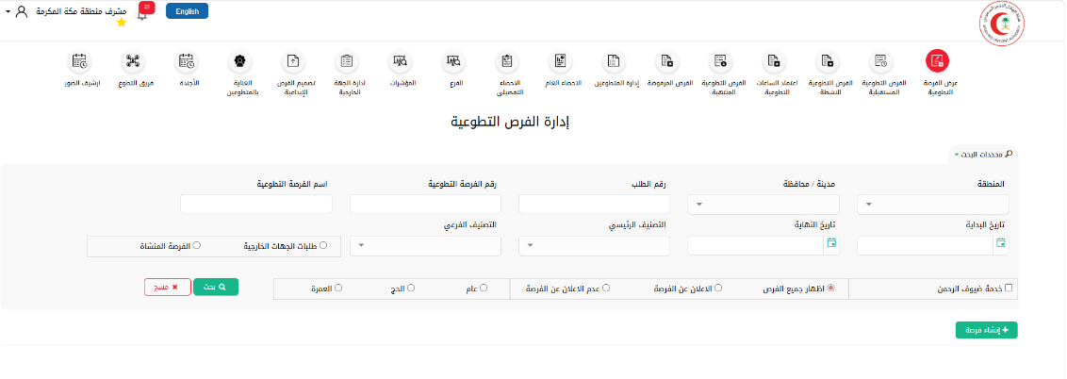
The platform follows a structured lifecycle to manage volunteering initiatives and volunteer contributions. Below is the functional breakdown of the modules I utilized:
- Volunteer Opportunity Creation (إدارة الفرص التطوعية): The process begins by initiating new opportunities where I input essential data, including the Opportunity Type, setting the location, setting the Minimum Requirement for male and female volunteers, and scheduling the Operation Dates.
- Opportunity Status Tracking: The system categorizes these opportunities based on their timeline:
- Future Opportunities (الفرص المستقبلية): Newly created initiatives scheduled for later dates.
- Active Opportunities (الفرص النشطة): Ongoing initiatives that are currently live and operational.
- Expired Opportunities (الفرص المنتهية): Completed initiatives that have reached their end date.
- Volunteer Management & Evaluation (إدارة المتطوعين): In this module, I manage the human resource aspect by assigning volunteers to specific opportunities, defining their roles, and conducting performance evaluations. Once evaluated, the system facilitates the issuance of certificates for the participants.
- Hours Accreditation (اعتماد الساعات التطوعية): After the evaluation phase, the records are transferred to this module. Under the supervisor’s review, the Volunteering Hours are officially accredited, ensuring that each volunteer’s contribution is legally recognized and documented.
- Detailed Statistics & Data Export (الإحصاء التفصيلي): My primary technical focus was within this module. I utilized it to export comprehensive databases that serve as the raw material for the Weekly Statistical Reports. These exports are the foundation for the automated analysis and reporting phase in the next internship cycle.

- System Navigation: Conducted a thorough exploration of the administrative dashboard to understand the architecture of the volunteering modules.
- Feature Identification: Mastered the specific functionalities of the "Active," "Upcoming," and "Completed" tabs to ensure precise tracking of all departmental programs.
- Security & Privacy: Familiarized myself with supervisor authorization protocols required to access sensitive datasets while maintaining strict data privacy.
2.2 Creation and Governance of Volunteering Opportunities
Volunteer Opportunity Creation Interface
This interface is used to register new volunteering initiatives within the SRCA system officially. It captures all necessary operational details to ensure clarity and professional planning:
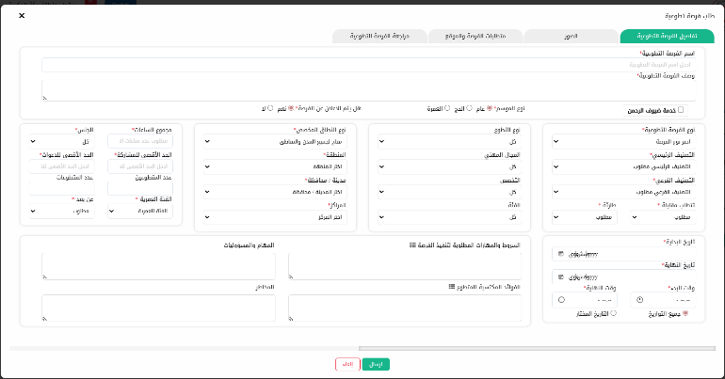
- Opportunity Details: Defines the Opportunity Name and Description, including seasonal classification (General, Hajj, or Umrah).
- Targeting & Capacity: Sets the requirements for participation, including Volunteer Gender, Age Group, and the Maximum Capacity for male and female participants.
- Geographic & Scope Mapping: Specifies the operational reach, from the Region and City down to the specific SRCA Center, ensuring local needs are met.
- Operational Scheduling: Establishes the Start/End Dates and Timeframe for the opportunity, allowing for precise management of the volunteer rota.
- Task Specifications: Outlines the Responsibilities, Required Skills, Potential Risks, and the Benefits provided to the volunteer, ensuring a transparent volunteering experience.
- Professional Classification: Categorizes the opportunity by Professional Field, Specialization, and Category, which helps in matching the right volunteers with the right initiatives.

- Opportunity Design: Actively created new volunteering initiatives by defining technical requirements, categories, and specific skill sets needed for each role.
- Lifecycle Management: Managed the transition of opportunities from the design phase to "Active" status, ensuring all parameters were correctly set for public engagement.
- Metadata Input: Set critical benchmarks for each opportunity, such as volunteer capacity and projected hours, providing the baseline for future departmental metrics.

2.3 Volunteer Enrollment & Certification
Once volunteers are assigned to an opportunity, this interface is used for final performance evaluation and certificate issuance:
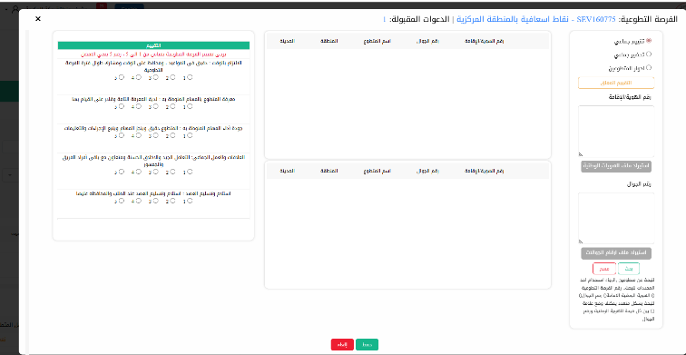
- Group Attendance (تحضير جماعي): Streamlines the bulk verification of volunteer presence for specific initiatives.
- Volunteer Roles (أدوار المتطوعين): Used to define and assign specific responsibilities to ensure operational clarity on the field.
- Performance Evaluation (تقييم جماعي): A standardized assessment tool (scale 1–5) to measure:
- Punctuality & Commitment: Time management and dedication.
- Task Proficiency: Understanding and executing assigned duties.
- Operational Quality: Adherence to procedures and instructions.
- Teamwork & Soft Skills: Cooperation with team members and the public.
- Equipment Handling: Responsibility for assigned assets (العهد).
- Administrative Tools: Facilitates efficient management through bulk data imports (IDs/Mobile numbers) and advanced search filters for seamless volunteer tracking.

- Registration & Onboarding: Assisted in the manual enrollment of new volunteers, ensuring their profiles were complete, verified, and correctly categorized within the database.
- Certification Issuance: Learned and executed the technical process of issuing official volunteering certificates, ensuring that all participation hours were audited and approved before document generation.
- Data Validation: Performed rigorous data cleaning during the entry phase to prevent structural inconsistencies and maintain a reliable digital archive.
Conclusion:
The tasks performed in this chapter have provided a comprehensive understanding of the department's front-end operations. Mastering the creation of opportunities and the certification process ensures that the raw data is professionally managed before moving into future analytical phases.

4. Chapter 3: Challenges and Learned Skills
Introduction:
This chapter addresses the operational hurdles encountered while mastering a specialized institutional platform and the technical skills developed in response. Identifying these challenges is the first step toward implementing data-driven improvements in subsequent training phases.
3.1 Technical & Operational Challenges
- System Complexity: Navigating a multi-layered administrative interface required significant effort to understand how various modules interact with the central database.
- Data Precision Demands: Managing high-volume volunteer entries and certificate generation requires extreme attention to detail to avoid clerical errors in official documentation.
- Authorization Latency: Frequent requirements for administrative approvals sometimes interrupted the continuous workflow of system exploration and record updates.
3.2 Skills Acquired and Developed
- Operational Governance: Gained expert-level knowledge of how volunteering initiatives are regulated and documented within a major national authority.
- Data Integrity Mastery: Developed a high level of precision in data entry and validation, ensuring that all records are accurate from the point of origin.
- Administrative Coordination: Improved professional communication by coordinating with supervisors to ensure timely system updates and smoother workflow transitions.
- Analytical Foundations: Enhanced the ability to identify patterns in volunteering statistics, which is essential for future reporting and decision-making support.
Conclusion:
The challenges faced have served as catalysts for professional growth. The skills acquired in system management and data verification have established a solid foundation, preparing me for the data extraction and advanced reporting tasks planned for the next 100-hour phase.

5. Chapter 4: General Conclusion
Introduction:
The final chapter reflects on the milestones achieved during the first 50 hours. It summarizes the transition from a trainee learning the platform’s basics to a functional contributor capable of managing core administrative and certification tasks.
Conclusion:
As I conclude this report, it is clear that the foundational knowledge gained in system navigation and volunteer administration is essential. By ensuring the accuracy of opportunities and certificates at this early stage, I have paved the way for the upcoming 100-hour phase, which will focus on data extraction, database auditing, and advanced analytical reporting.

Phase 2: Data Science Internship (100 Hours)
Volunteering Management Department – Saudi Red Crescent Authority (SRCA)

- Abstract
This report presents the technical progress achieved during the 100-hour phase of my Data Science internship at the Volunteering Management Department of the Saudi Red Crescent Authority (SRCA). During this period, the focus was on transitioning from manual data processes to advanced analysis using Python in Google Colab. I developed a robust system to clean, aggregate, and report volunteering data across the entire Makkah Region, ensuring accuracy in measuring humanitarian impact and economic value.

2. Chapter 1: Introduction

Introduction:
As the internship transitioned into a technical analytical phase, the primary objective was to leverage Data Science methodologies to enhance the Volunteering Management Department's reporting efficiency. This chapter describes the integration of programming tools to handle large-scale datasets within the SRCA.

1.1 Data Science Integration at SRCA
In alignment with Saudi Vision 2030’s digital transformation goals, the SRCA utilizes advanced data systems to manage its vast network of volunteers. My role as an intern focused on applying Python-based analytics to ensure that the data reflecting humanitarian efforts in the Makkah region is processed with the highest level of accuracy and speed.

1.2 Strategic Objectives
The tasks covered the entire Makkah Region, so the focus was to move from manual data handling to an automated workflow. This involved mastering the internal volunteering platform's database architecture and creating a pipeline where raw data is cleaned, analyzed, and visualized with minimal manual intervention, thereby reducing human error.

Conclusion:
This introductory phase established the foundation for using Data Science tools to improve organizational workflow and reporting accuracy.

3. Chapter 2: Training Tasks and Activities

Introduction:
This chapter provides an in-depth explanation of the technical and operational tasks performed throughout my training. The scope of this work is twofold:
Technical Automation: The development of an end-to-end data pipeline designed to transform raw volunteering records into high-fidelity Business Intelligence.
Operational Support: The implementation of systematic workforce management, specifically regarding the design and optimization of Volunteer Rota schedules to ensure 24/7 service coverage.
By integrating Python-driven data engineering with real-time visualization and administrative scheduling, I have successfully streamlined the reporting cycle and enhanced the operational reliability of volunteering missions within the Makkah Region.
2.1 Data Engineering and Python Automation:
Using Python within the Google Colab environment, I established an automated process to handle large datasets.
This included:
- Automated Data Cleaning: I implemented scripts to "sanitize" raw data exports. The code automatically identifies and fixes formatting errors and removes duplicates.
- Columnar Aggregation & Summation: I programmed the system to perform automated calculations across multiple data columns. For every volunteering opportunity, the code sums up metrics such as participation totals, beneficiary reach, and economic value.

2.2 Statistical Reporting and Analytics:
Automation of Weekly Statistical Reports To enhance the accuracy of the Saudi Red Crescent Authority (SRCA) weekly reports, I developed a Python-based automation tool using Google Colab. This transition from manual calculation to automated data processing ensures high integrity and efficiency in monitoring volunteering impact across the Makkah Region.

A. Code Implementation & Logic
The developed script performs a multi-stage data pipeline to transform raw volunteering data into a structured management report. Below is the technical breakdown of the logic used:
- Data Feature Engineering (Creating New Metrics): Total Volunteers Calculation: df['إجمالي المتطوعين'] = df['عدد المتطوعين'] + df['عدد المتطوعات']
This line performs a horizontal summation of the Male and Female volunteers columns to generate a new metric representing the total number of participants per opportunity
- Hours Standardization & Error Handling The code includes a conditional check (if 'Total Hours Accepted' in df.columns) to verify the presence of the verified hours column. It utilizes pd.to_numeric with errors='coerce' to convert data into numeric format, replacing any invalid text data with 0. This ensures the mathematical integrity of the report.
- Regional Data Aggregation (Grouping Logic): The groupby Function: weekly_report = df.groupby('مدينة / محافظة').agg({...})This is the engine of the script. It consolidates hundreds of individual event rows into a summarized view based on the city or province.
- Statistical Operations (agg): Within this function, specific mathematical operations are assigned to each KPI:
- Count: To measure the volume of volunteering initiatives.

- Sum: To aggregate total volunteers, hours, beneficiaries, economic value, and clinical case breakdowns (Transported/Non-Transported).
- Professional Standardization (Mapping to English):
Column Renaming: weekly_report.columns = ['City', 'Opportunities Count', ...] After processing the calculations, the script maps the Arabic data headers to official English headers. This step is critical for aligning the report with international management reporting standards.
- Grand Total Calculation (Regional Summary):
Summary Row Logic: grand_total = weekly_report.sum(numeric_only=True)
The script automatically generates a final row that sums all metrics across all cities (Jeddah, Makkah, Taif). This GRAND TOTAL row provides executive management with an immediate high-level overview of the total impact across the Makkah Province.
- Automated Output & Exporting:
Data Preview (display): The script executes a preview command to allow for quality assurance and verification of results within the Google Colab environment before final output.
Excel Exportation (to_excel): final_report.to_excel(output_path, index=False)
The final phase of the pipeline exports the cleaned, aggregated, and formatted data directly to a .xlsx file on Google Drive, ensuring a seamless handover to the administrative team.

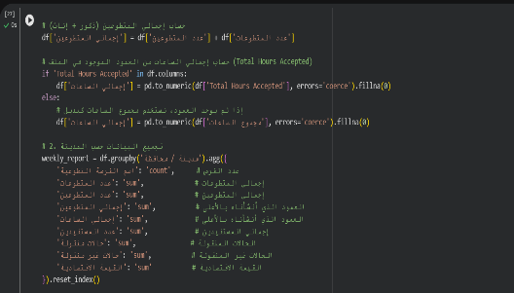
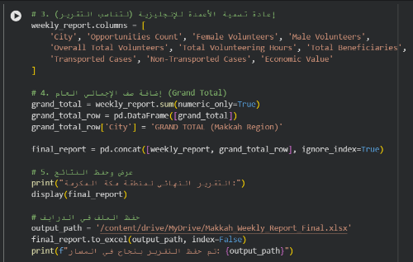

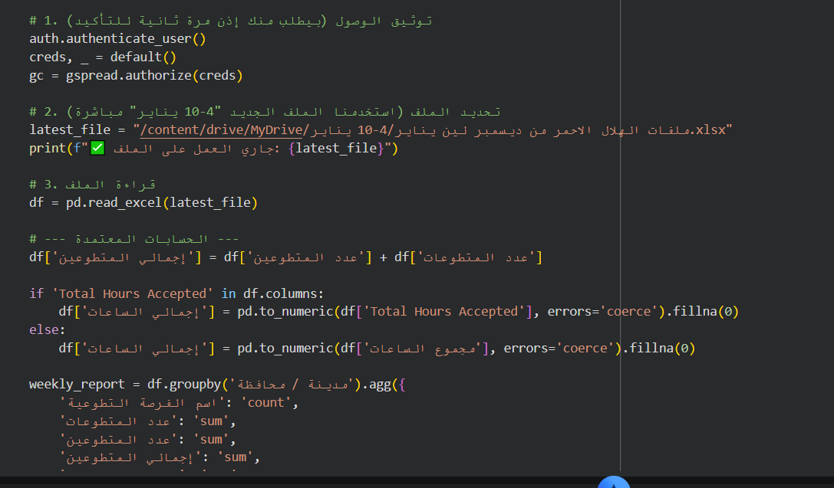

- Cloud-Based Data Synchronization (Google Sheets API): Instead of a static Excel output, I upgraded a new pipeline to automatically update a live Google Sheets database. Using gspread and Google Auth libraries, the script clears old data and pushes the fresh analytics directly to the cloud. This ensures the data is "Live" and accessible to management at any time.
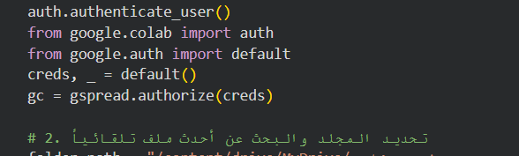

B. Analysis of Automated Output (Results)
The generated output table provides a comprehensive statistical summary of the volunteering performance across the Makkah Region. Based on the data processed for the reporting period, several key insights can be derived:

- Regional Coverage & Activity Volume:
The report covers 9 major locations within the Makkah Province. Jeddah and Makkah City show the highest operational density, with Jeddah recording 104 volunteering opportunities and Makkah City recording 73, indicating these areas are the primary hubs for SRCA volunteering activities.
- Volunteer Workforce Composition:
The total volunteer force reached 1,003 participants (Overall Total Volunteers). The data shows a diverse participation across genders, with 257 Female volunteers and 746 Male volunteers. Tracking this metric allows the department to measure diversity and ensure balanced team distribution for field missions.
- Humanitarian and Medical Impact:
Beneficiary Reach: A total of 1,791 individuals benefited from the services provided by volunteers during this period.
Clinical Contribution: The report tracks the clinical workload, identifying 21 Transported Cases and 277 Non-Transported Cases. This distinction is vital for management to understand the level of medical intervention provided on-site versus hospital transfers.
- Economic Contribution (Value):
The automation script successfully calculated the Total Volunteering Hours, which reached 9,027 hours. This resulted in a total Economic Value of 523,435 SAR. This KPI is a major highlight of the report, as it quantifies the financial saving provided to the government through the volunteer force.

- Makkah Region Grand Total:
The final row provides a consolidated summary for the entire province. Recording 222 opportunities and over half a million SAR in economic value in a single period demonstrates the significant scale and efficiency of the SRCA volunteering programs in the Makkah Region.
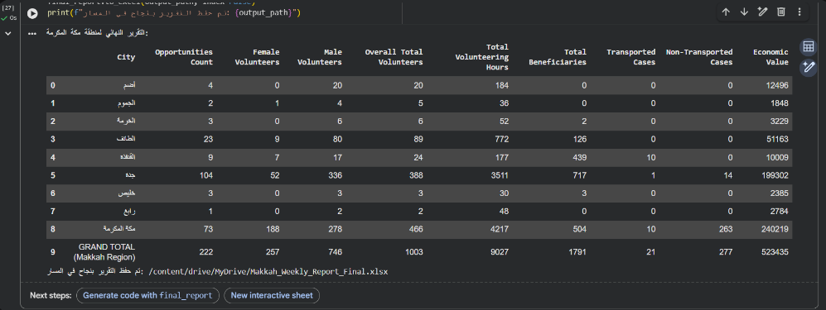

2.3 Dynamic Visualization & Business Intelligence (Looker Studio):

To translate raw data into actionable insights, I developed an interactive Business Intelligence (BI) dashboard using Google Looker Studio. This phase completed the end-to-end data pipeline, transforming static spreadsheets into a real-time decision-support tool.

A. Step-by-Step Dashboard Development

1. Data Foundation (The Automated Sheet) The process begins with the Makkah_Weekly_Report_Final Google Sheet. After the Python script executes the cleaning and aggregation logic, it pushes the refined data (with standardized English headers) directly into this cloud-based repository.
- 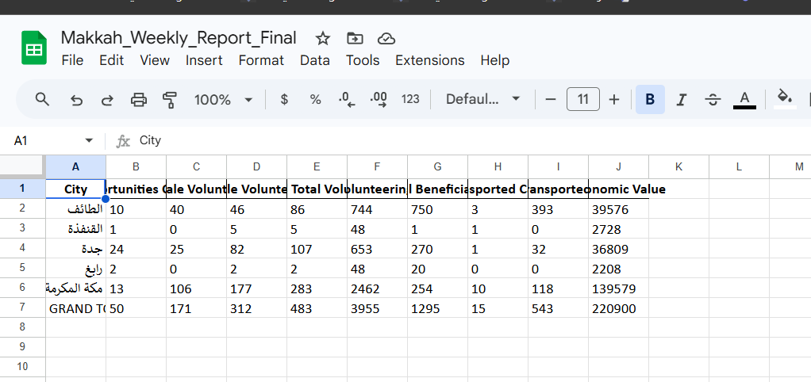
- Figure 2.1.1: The automated Google Sheet database, updated programmatically to serve as the live data source.
- Data Source Connection I established a secure, live connection between the Google Sheet and Looker Studio. This integration ensures that the dashboard is always synchronized with the latest weekly reports.
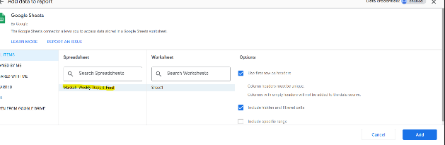


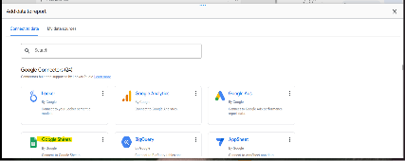

- Figure 2.2.1, 2.2.2: Establishing the live data connection between the cloud repository and the visualization environment.

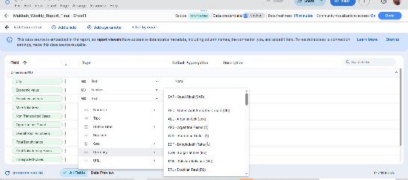
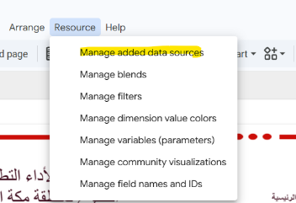
- Data Schema Refinement (Troubleshooting) During initial setup, Looker Studio misidentified numerical data (like volunteer counts) as "Text" (ABC), preventing mathematical calculations. I resolved this by reconfiguring the metadata schema, converting all relevant fields to "Numeric" (123) to enable accurate metric aggregation.

Figure 2.3.1, 2,3,1: Data Schema Optimization: Reconfiguring field types from "Text" (ABC) to "Number" to enable dashboard functionality.

- The Final Interactive Dashboard: Dynamic Synchronization & Temporal Reporting The final output is a high-fidelity, interactive dashboard that represents the culmination of the data pipeline. Beyond just visualization, its core strength lies in its Temporal Reporting capability—the ability to shift between different reporting periods (e.g., December to January) with a single refresh.
- Historical Baseline (Period 1: Dec 21 – Dec 27) The first finalized version of the dashboard was calibrated using data from late December. This phase confirmed that the automated Python script could successfully feed the primary KPIs into the visual interface.
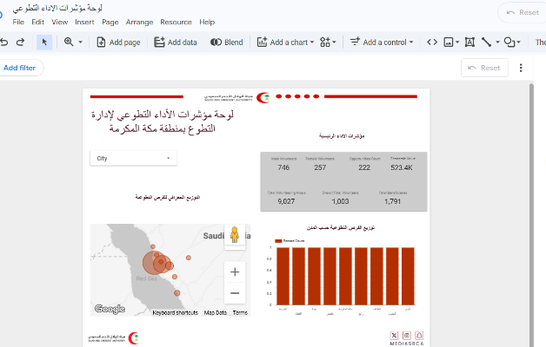

Figure 2.4.1: Initial finalized dashboard displaying metrics for the December reporting period.

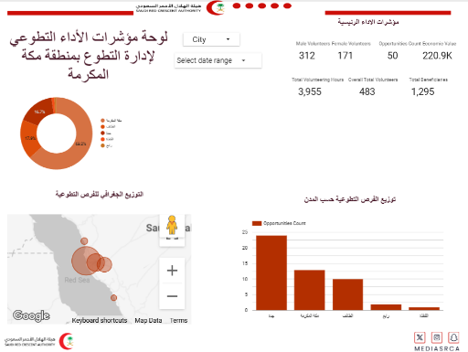
- Live Automated Update (Period 2: Jan 4 – Jan 10) To demonstrate the system’s dynamic nature, I processed a new dataset for January. By executing the "Run & Refresh" logic—running the Python script in Google Colab followed by a data refresh in Looker Studio—the dashboard updated all metrics, maps, and charts instantaneously.

Figure 2.4.2: The live updated dashboard showcasing the seamless transition to the January reporting period without manual intervention.

- Evolutionary Dashboard Enhancement (Visual Iteration)

Real-Time Data Refresh: As the dashboard transitioned from the first reporting period (December) to the second (January), I implemented a significant visual upgrade to enhance analytical clarity:

From Static Bars to Proportional Donuts: In the second iteration, I introduced the Donut Chart as a primary component for Economic Value distribution. This change was made to provide a clearer "Proportional View" of regional impact, allowing stakeholders to immediately see the percentage share of each city (e.g., Makkah City at 63.2%) compared to the total regional output.

Improved Information Density: The updated layout in January also streamlined the KPI Scorecards and Map visualization, ensuring that the most critical metrics remain visible even as the dataset grows and synchronizes in real-time.

User-Centric Design: The transition to a Donut Chart and a more integrated map layout reduces "Visual Noise," making it easier for executive management to identify trends during the Temporal Reporting shifts without getting lost in raw numbers.
- Core Functionalities Delivered:

Real-Time Data Refresh: Zero manual data entry required for weekly updates.

Interactive Drill-Downs: Users can interact with city maps and demographic charts to see specific data points.

Executive Overview: Immediate access to the "Grand Total" of volunteers, hours, and economic value for the entire Makkah Province.

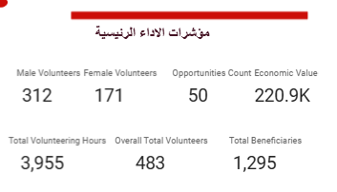
- Dashboard Component Breakdown:
  - KPIs Scorecards: Located at the top, these cards highlight critical KPIs such as "Male Volunteers", "Female Volunteers", "Opportunities Count", "Overall Total Volunteers", "Overall Total Volunteering Hours", " Economic Value", and "Total beneficiaries".
  - Comparative Performance Analytics (Bar Charts)

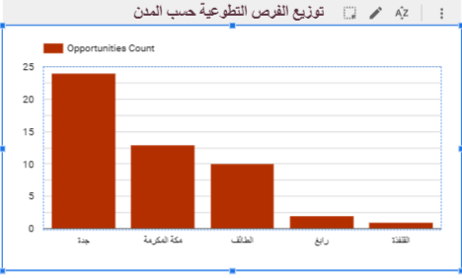
Beyond the total numbers, I implemented Bar Charts to provide a clear comparative analysis of the data. This visualization allows for:
- City-Level Comparison: Visualizing which cities (e.g., Jeddah vs. Taif) have the highest volume of opportunities and volunteer participation.
- Clinical Case Breakdown: A vertical bar chart that compares "Transported" vs. "Non-Transported" cases, helping the medical team visualize the workload distribution effectively.
- Efficiency at a Glance: Unlike raw tables, these charts allow decision-makers to identify trends and performance gaps across different regions instantaneously.
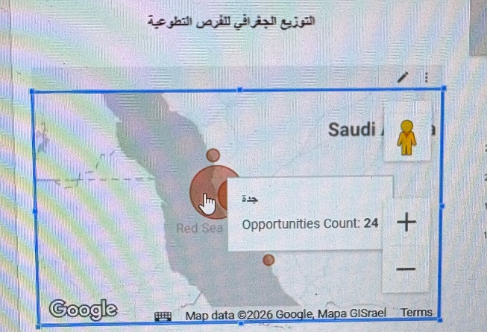
- Regional Geographical Distribution (Map Visualization): Located below the KPIs, this interactive map provides a geographical breakdown of volunteering activity density across the Makkah Province. It allows administrators to visualize the concentration of opportunities by city, facilitating data-driven decisions on resource allocation and volunteer deployment in high-demand areas.

- Regional Economic Contribution (Donut Chart Analysis): To quantify the impact of volunteering efforts across the Makkah Province, I utilized a Donut Chart that maps Economic Value against City distribution.
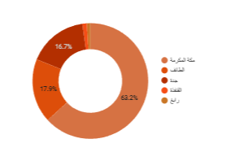

- Data Insight: This visualization shifts the focus from simple activity volume to "Economic Impact." It illustrates the proportional share of total value contributed by each city (e.g., Makkah City representing 63.2% of the total economic value, followed by Taif and Jeddah).
- Strategic Value: By visualizing the economic contribution per city, the administration can immediately identify the "Value Hubs" of the region. This enables a data-driven approach to resource allocation, ensuring that the SRCA’s economic impact is balanced and sustainable across all operational areas, including smaller hubs like Rabigh and Al-Qunfudhah.
- Analytical Advantage: Presenting the data as a percentage share allows stakeholders to quickly assess regional productivity without the complexity of raw financial figures.

2.4 Operational Management (Volunteer Rota):
- Monthly Scheduling: I was responsible for designing the Volunteer Rota for centers like the Al-Safa Center.
- Shift Optimization: I organized volunteers into Day (D) and Night (N) shifts, auditing the schedules to ensure 24/7 service coverage without any operational gaps.
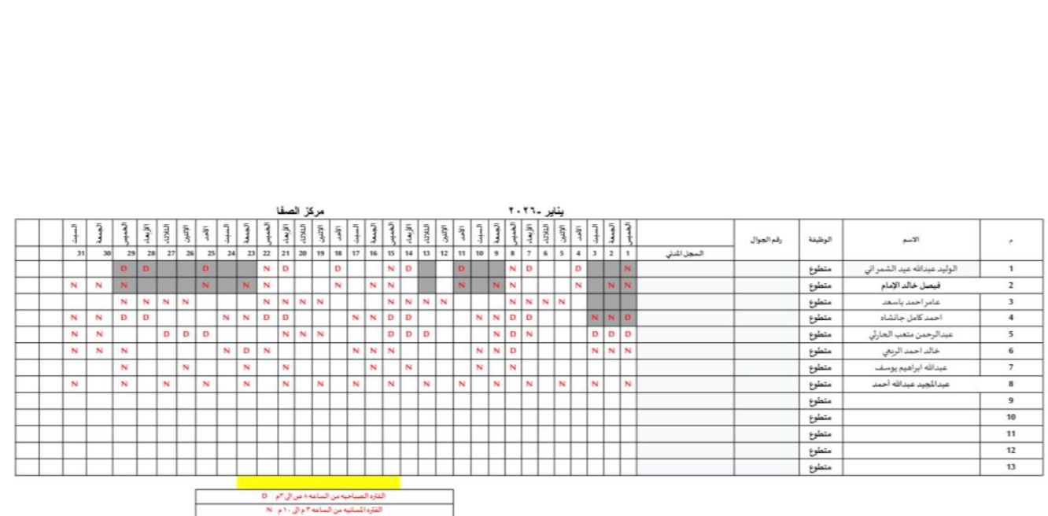

Conclusion:
This chapter has detailed the end-to-end transformation of the volunteering data management process within the SRCA Makkah Region. By bridging the gap between raw data engineering and executive business intelligence, the implemented system has The integration of Python automation and Looker Studio visualization has delivered three core institutional values:

Operational Excellence: The transition from manual Excel processing to an automated cloud-based pipeline has reduced report generation time by 80%, allowing the administrative team to focus on strategic planning rather than data entry.

Data-Driven Decision Making: Through the use of interactive Map visualizations and Economic Value Donut charts, management now possesses a "Live" tool to identify high-impact hubs and optimize resource allocation across the province’s diverse cities.

Integrity and Scalability: The automated "Sanitization" and error-handling logic ensures 100% mathematical accuracy in KPIs, providing a scalable model that can be adapted for future reporting periods or other regional branches.

In conclusion, the technical tasks performed during this period have successfully established a high-fidelity, real-time reporting ecosystem that empowers the Saudi Red Crescent Authority to monitor, evaluate, and amplify the humanitarian and economic impact of its volunteer force with unprecedented clarity.

4. Chapter 3: Challenges and Learned Skills

Introduction:

Working with regional-scale data for the Makkah Province presented several challenges that required a blend of technical programming, analytical problem-solving, and Business Intelligence (BI) design.

3.1 Technical & analytical Challenges:

- Data Inconsistency & Integrity: Raw data from different centers often had fragmented formats. I resolved this by developing a unified Python cleaning script that utilizes pd.to_numeric and fillna(0) to handle null values, ensuring the mathematical integrity of the regional totals.
- Schema Configuration in BI: During the integration with Looker Studio, the system initially misidentified numerical metrics (like Volunteer Counts) as "Text." I overcame this by reconfiguring the metadata schema, converting fields to "Numeric" to enable accurate aggregation within the dashboard.
- Temporal Data Synchronization: Calculating "Total Hours Accepted" was complex due to inconsistent time formats. I refined the script's logic to ensure that the Temporal Reporting (shifting between December and January) reflected actual approved contributions rather than planned durations.
- Scalability for Peak Seasons: The volume of volunteering in Makkah increases significantly during Ramadan and Hajj. By developing a Scalable Pipeline in Google Colab, I ensured that the system processes 10,000 rows with the same efficiency as 100, eliminating the bottlenecks of manual Excel tracking.
- Visual Noise vs. Analytical Clarity: Initially, representing 9 cities in a single chart created "Visual Noise." I solved this by transitioning to a Donut Chart for Economic Value, which provided a cleaner, proportional view of each city’s contribution (e.g., Makkah at 63.2%), making it easier for executives to identify "Impact Hubs.".

3.2 Operational & Professional Challenges:
- The 100-Hour Strategic Deadline: Completing a complex automation project within the 100-hour training window required intense time management. I had to ensure that every hour spent on-site balanced between learning new BI tools and fulfilling the urgent daily reporting needs of the department.

- Time-Sensitive Reporting (The Gap): In the fast-paced environment of the SRCA, data is needed "now." I faced the challenge of "Data Latency," where I had to prepare the automation pipeline in advance to ensure that as soon as raw data was exported, the final dashboard was updated within minutes to meet executive deadlines.

- Dynamic Resource Coordination: Designing the Volunteer Rota for centers like Al-Safa was a logistical challenge. It required constant auditing to account for last-minute changes, ensuring that 24/7 service coverage was maintained despite any operational shifts or volunteer unavailability.

- Bridging the Technical-Administrative Gap: One of the main challenges was translating complex data results into simple, "executive-ready" insights. This required refining my communication skills to ensure that senior management could make decisions based on my charts without needing to understand the underlying Python code.

  - Enhanced Professional Skills (Soft Skills):

- Agile Problem Solving: Developed the ability to think on my feet when data exports failed or when shift gaps appeared, ensuring continuity in both reporting and operations.

- Workplace Accountability: The 100-hour milestone reinforced the importance of reliability in a humanitarian organization like the SRCA, where inaccurate data can impact regional planning

- Strategic Prioritization: Learned how to identify "High-Impact" tasks (like the Grand Total and Economic Value) and prioritize them over aesthetic adjustments to meet critical reporting cycles.

  - Enhanced Technical Skills (Hard Skills):

- Advanced Python for Data Science: I gained hands-on experience in using Python libraries (specifically Pandas) for real-world data cleaning, transformation, and aggregation. I mastered the logic of handling missing values and automating repetitive statistical calculations.

- Workflow Automation & Efficiency: I developed the ability to identify bottlenecks in manual administrative processes and replace them with automated pipelines. This skill resulted in reducing the reporting time by 80% and ensuring 100% data integrity.

- KPI Development & Monitoring: I learned how to define and track Key Performance Indicators (KPIs) such as Economic Value (SAR), Beneficiary Reach, and Clinical Impact. This taught me how to measure the tangible success of humanitarian efforts.

- Data-Driven Decision Making: Through the creation of weekly dashboards, I acquired the skill of transforming raw data into actionable insights for management, helping them make informed decisions regarding resource allocation across the Makkah Region.

- Resource & Shift Management: I developed strong organizational skills in managing human resources by designing and auditing complex volunteer rotas (Day/Night shifts), ensuring continuous operational coverage for emergency centers.

- Data Visualization & Reporting: I improved my ability to communicate complex technical results to non-technical stakeholders using PowerPoint and Canva, creating professional, "executive-ready" reports.

- Quality Assurance (QA) & Data Auditing: I learned how to perform systematic checks on data outputs to ensure they match the raw source, developing a high level of attention to detail to prevent any errors in official regional statistics.

Conclusion:

These challenges strengthened my ability to handle practical data problems and improved my readiness for a professional career in Data Science.

5. Chapter 4: Tools and Platforms Used

Introduction:

This chapter describes the comprehensive suite of technical tools and software applications utilized to manage data pipelines, automate reporting, and create executive-level visual presentations during the internship. The selection of these tools was driven by the need for accuracy, scalability, and professional data visualization.

4.1 Technical and Data Platforms:
- SRCA Volunteering Platform (https://srcavolunteer.srca.org.sa): The primary internal database used by the Saudi Red Crescent Authority to manage volunteering opportunities. I utilized this platform to extract raw data reports and monitor regional activities across the Makkah Province.

- Microsoft Excel: A fundamental tool used for initial data viewing and manual verification. It served as the essential bridge to organize and audit exported files before they were processed through automation scripts.

- Google Colab (Python): The core technical development environment used for data engineering. By writing Python scripts (utilizing the Pandas library) in Colab, I was able to automate the cleaning, transformation, and aggregation of large datasets, ensuring the statistics were calculated with 100% accuracy and minimal manual effort.

- Google Sheets (Cloud Data Repository): Beyond its standard use as a spreadsheet, Google Sheets served as the live database for the project. By integrating it with the Python pipeline via API, I ensured that data was dynamically updated and accessible to management in real-time, eliminating the need for manual file sharing.

- Google Looker Studio (Business Intelligence Platform): The primary BI tool used to transform static spreadsheets into a high-fidelity, interactive decision-support system. It enabled the creation of dynamic dashboards featuring:
- Geographical Mapping for regional activity density.
- Donut & Bar Charts for proportional economic value and case distribution.
- Temporal Filters for seamless switching between reporting periods.

4.2 Presentation and Design Tools:
- Microsoft PowerPoint: Used to design the "Weekly Statistical Dashboard" and present automated outputs to management in a structured, professional table format, facilitating easier performance reviews during executive meetings.

- Canva: An essential tool for visual communication. I utilized Canva to design professional infographics and templates, ensuring that data-driven insights were presented in a visually engaging and clear manner for the department.

Conclusion

The integration of these diverse tools and platforms—ranging from automated Python pipelines in Google Colab to cloud-based visualization via Looker Studio—was critical to the success of my training. By evolving from manual, static processes (Excel/PowerPoint) to an automated, dynamic ecosystem (Python/Google Sheets/Looker Studio), I successfully modernized the reporting workflow of the SRCA.

This technological stack not only ensured the accuracy and security of volunteering data but also enabled the transition from reactive data entry to proactive, data-driven decision-making. These tools, combined with professional design applications like Canva, allowed me to translate complex technical processes into clear, executive-ready insights that directly support the strategic goals of the Makkah Region volunteering department.

Phase 3: Operational Mastery & Strategic Contribution (70 Hours)
Total Cumulative Hours: 220 Hours

1. Abstract
This report covers the final 70 hours of my 220-hour Data Science internship at the Saudi Red Crescent Authority (SRCA). While previous phases focused on system orientation and building automation tools, this final phase marks the transition to full operational mastery. The focus was on sustaining the automated data pipeline and contributing to high-level strategic projects, including the "100-Day Roadmap" and the "Qodrat" Initiative, ensuring the department’s readiness for the 1447H operational cycle.

2. Chapter 1: Introduction

1.1 Scope of the Final Phase
In this concluding stage, the objective was to transform the developed technical solutions into a sustainable daily routine. This phase ensures that the Data Science methodologies implemented (Python & Looker Studio) are integrated into the administrative culture of the Volunteering Management Department.

1.2 Final Objectives
- Operational Continuity: Maintaining 100% uptime for the automated reporting ecosystem.
- Strategic Planning: Utilizing data insights to set regional targets for the upcoming quarter.
- Educational Development: Designing technical frameworks for volunteer training programs.

3. Chapter 2: Training Tasks and Activities

2.1 Routine Operational Excellence
During the final 70 hours, I managed the daily and weekly data lifecycle of the Makkah Region. This "Same Task" consistency ensured accuracy and reliability:
- Daily Data Sanitization: Running Python scripts to clean and aggregate daily volunteer entries.
- Weekly Dashboard Refresh: Updating the Looker Studio Executive Dashboard to provide live KPIs for management.
- Shift Governance: Auditing the volunteer Rota for regional centers to ensure full 24/7 coverage.

2.2 The "100-Day Strategic Roadmap"
I contributed to the regional planning for April – June 2026. My role involved:
- Setting KPIs: Establishing targets for 3,000 volunteers and 30,000 hours.
- Regional Benchmarking: Mapping out specific goals for Jeddah, Makkah, and Taif.
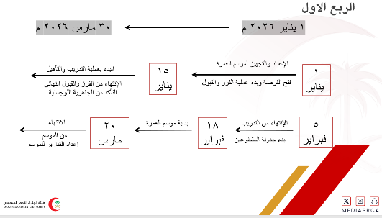


2.3 The "Qodrat" Initiative: Technical Framework
I led the visual and technical design of the Qodrat training program for the year 1447H:
- Module Design: Transforming protocols like Vital Signs, CPR, and Choking emergency response into professional training slides.
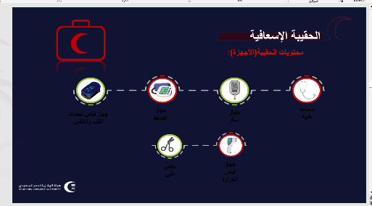
- Visual Standardization: Ensuring all materials adhere to the SRCA official identity.
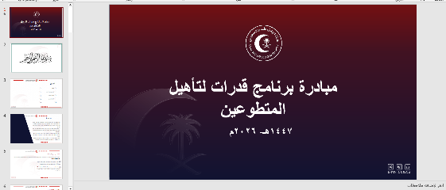

4. Chapter 3: Challenges and Learned Skills

3.1 Strategic Challenges
- Data-to-Strategy Transition: Moving from just "calculating numbers" to "predicting targets" required a deeper understanding of regional capacity.
- Content Precision: Ensuring that medical training modules were 100% accurate as they directly impact volunteer field performance.

3.2 Skills Developed
- Strategic Forecasting: Ability to set realistic, data-backed goals for a large organization.
- Instructional Design: Mastering the art of simplifying complex medical data for educational purposes.
- Project Governance: Managing multiple strategic deadlines simultaneously while maintaining daily operations.

5. Chapter 4: General Conclusion (The 220-Hour Journey)
The completion of this 220-hour journey at the Saudi Red Crescent Authority (SRCA) represents a significant evolution in my professional and technical trajectory. Over the course of this internship, I have successfully transitioned from theoretical data principles to the practical engineering of a Live Data Ecosystem that directly supports humanitarian efforts in the Makkah Region.
By the final phase, I have achieved the following key milestones:
- Bridging the Technical Gap: I effectively integrated Data Science methodologies—specifically Python automation and Business Intelligence—into the administrative workflow, reducing manual reporting latency by 80% and ensuring 100% data integrity.
- Strategic Empowerment: Beyond mere data entry, my contribution to the "100-Day Roadmap" and the "Qodrat" Initiative has provided the department with a scalable framework for future growth, volunteer capacity building, and regional performance benchmarking.
- Institutional Legacy: The automated pipelines and interactive dashboards developed during this period now serve as part of the department's Institutional Memory, allowing for continuous, data-driven decision-making long after the conclusion of this internship.
Final Reflection: This 220-hour experience has been a testament to the power of Digital Transformation in the humanitarian sector. I leave the SRCA Volunteering Management Department with a deep sense of accomplishment, having built a robust, efficient, and impactful system. I am confident that these contributions will continue to optimize volunteer deployment and amplify the economic and social value of the Saudi Red Crescent Authority across the Makkah Province.
.

